When I login I see the profile everytime. Can we have the dashboard as the landing page?
04/20 – you can point to the dashboard for the employees as well.

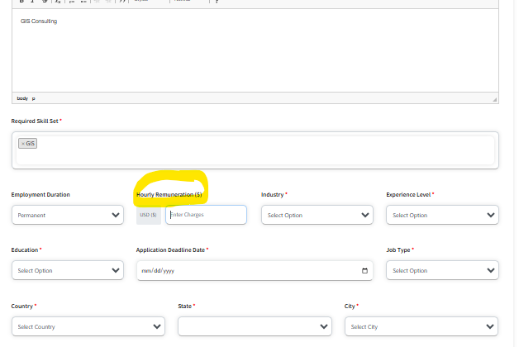
Can we have a yearly remuneration as well? Or change this to yearly remuneration?
04/20 – this still hasn’t changed.

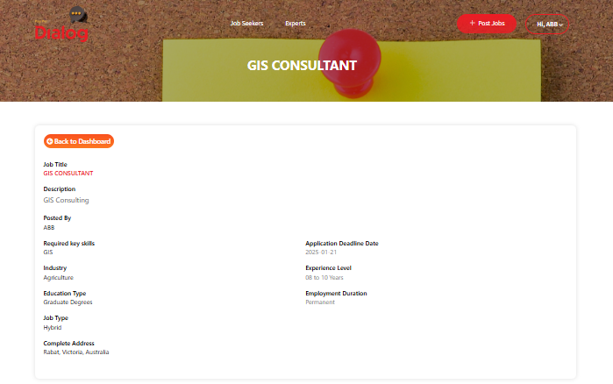
Can the look and feel (the banner, fonts etc) change to the other pages (like below)?
04/20 – the look and feel is still the same – hasn’t changed.

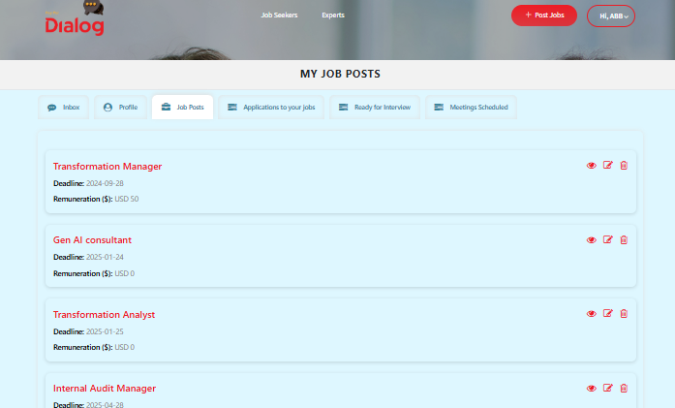
There is a back to dashboard button, which is good, but it takes us back to the job posts tab? Can we rewrite the button as “back to job posts”. Alternatively, we take the user back to dashboard.
04/20 – don’t see “back to job posts”
Based on the job requirements,
- Can we get a select list of candidates, right when we post a job, under “recommended employee”?
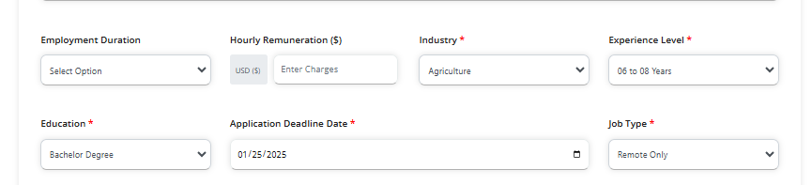
- This is where these filters should show the recommended employee; at this point it is blank:
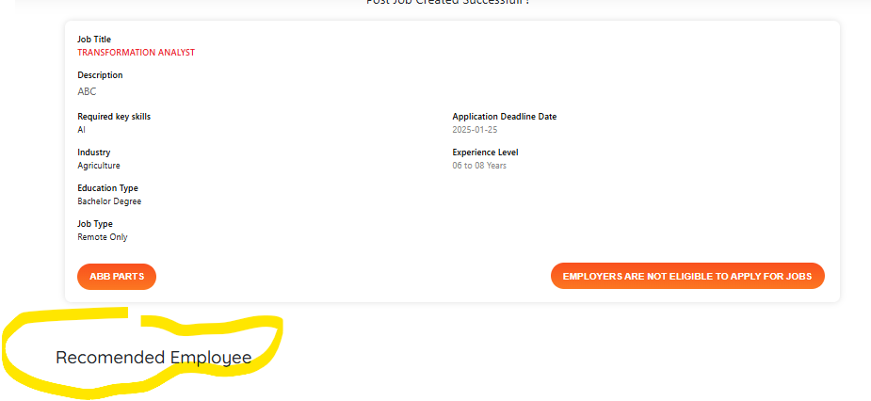

- Next to the Recommended job seekers list, should be rank based on the match.
- Also, the top ranked (or top 10) employees should have the chat and ready to interview buttons enabled as we want the employers to choose candidates too and not just depend on the applicants. There may be cases where no applicant meets the criteria of what the employers are looking for so they search in the pool. The search for candidates should also behave identically (top search results should have the chat and ready to interview buttons enabled.
04/20 – only see “ready for interview” and not the chat option.
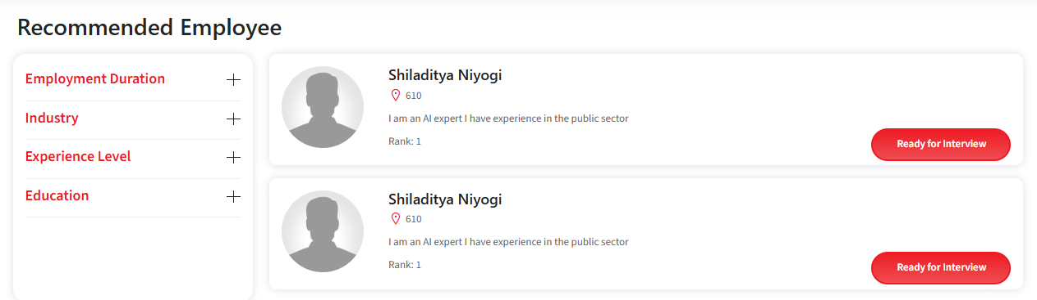

- Also the employer dashboard page should have more blocks of metrics/KPI’s –interviews conducted, time saved, average cost of interviews, payments made, as well as links to the account for the employer. The dashboard should also be a menu item.

- We should add an Account page for the employer, where we have details on the subscription, payment information, discontinue subscription, name/contact of admin, etc. The Dashboard can have a portion dedicated to this account type thing but it is more organized to have a separate page, and that is reflected as an item in the side menu.

- If a person has applied for three jobs, we should be allowed to schedule 3 meetings
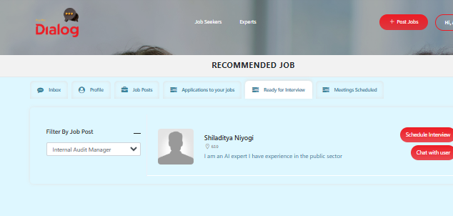

The meeting calendar can be made simple. I think you are working on it after my last feedback. It has a few errors:
For some reason when I selected a date it would show the prior date
It takes the whole availability for a meeting – if it can be broken down into half hour slots that would be great (like how Calendly does it)

04/20: It doesn’t show the hours to the company – just shows green slots
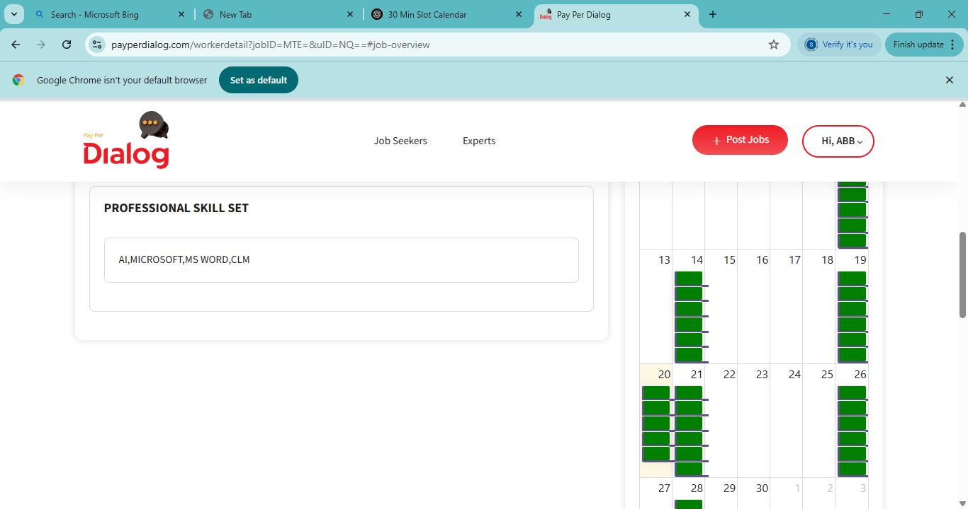
When I click on any slot it does not do anything.

There is no notification going to anyone
A slot is getting double booked
Also, for the candidate, we can let the candidate select availability dates in a more user friendly way (Calendly or Outlook online)
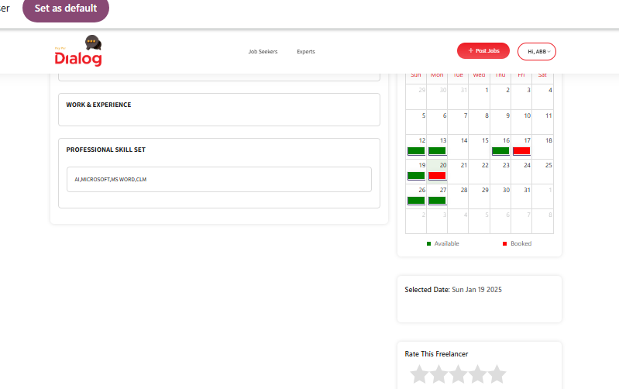
Also as an employer, when I select someone as ready for interview =, nothing happens after that to schedule the interview (this used to work earlier)
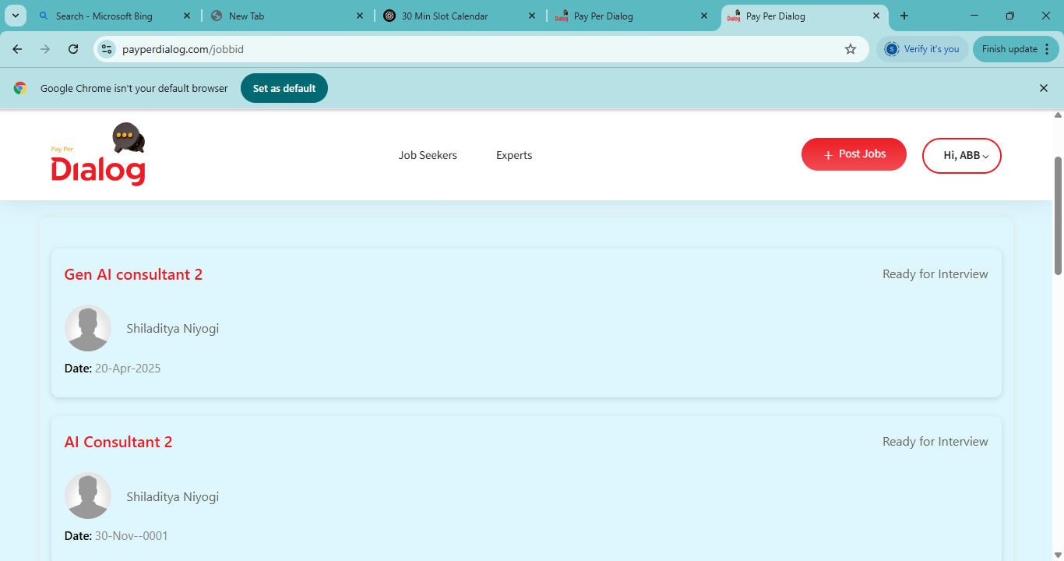

04/10 – these problems are still there. You can use some third party apps to make it look more succinct:
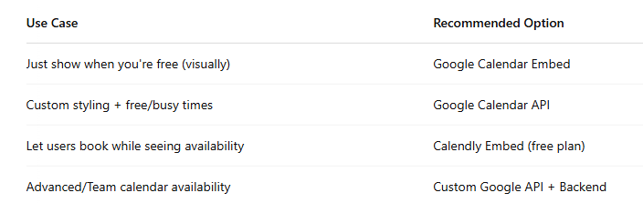

Employee

Please make all the changes that you are making for employee for the expert as well.
- Also can we add a self identify tab on the profile and call it out as optional, as some employers want to track this data for record keeping.
  - You can use the form from here - https://www.rfsuny.org/media/rfsuny/documents/careers/Self-ID-Applicants.pdf
04/20 – I do not see it there
- When I sign in I see that a dashboard that is blank. There should be a button for “Dashboard” on the left menu. On this Dashboard page, can we have a few metric type things here – e.g. pointers for profile, pointers for applying for jobs, a square explaining the number of jobs that have been applied to, the number of interviews attended, feedback from interviews received, number of logins, a pointer to the account specifics, etc.
- We have to add another “Account” page to describe the account, what subscription plan that person is on, if they need to add a credit card for payment, changing password option, discontinuing membership, etc. The Dashboard can have a portion dedicated to this account type thing but it is more organized to have a separate page, and that is reflected as an item in the side menu.
- 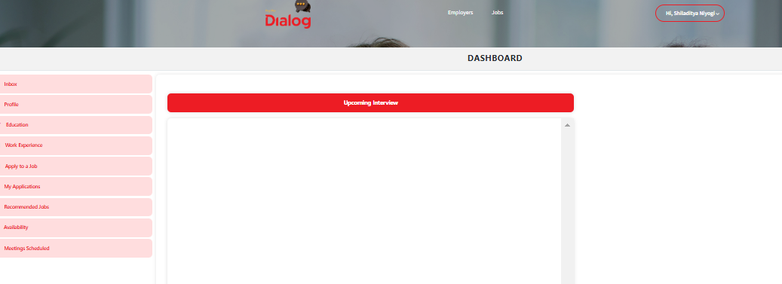
- Dashboard should have other metrics and account information. Some samples below:

  - 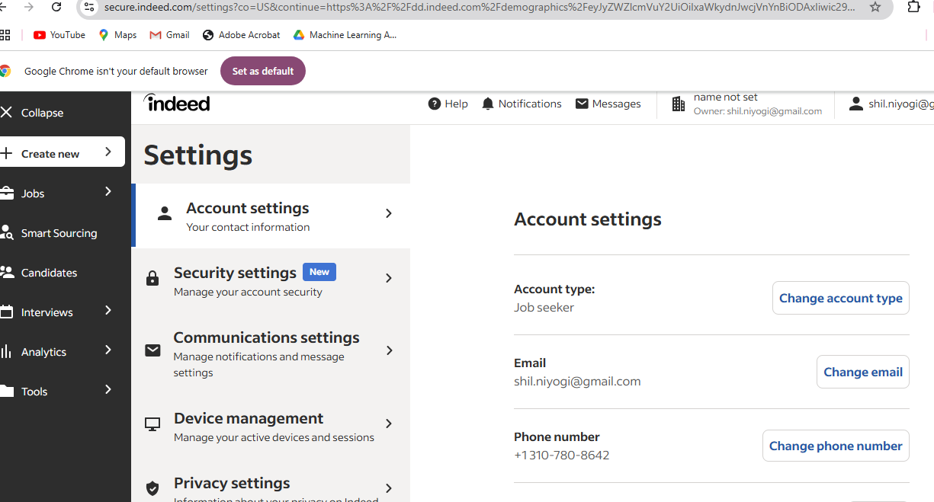
- 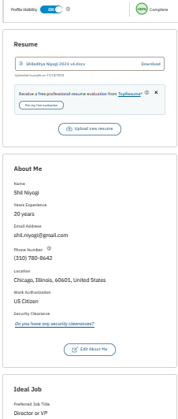
- 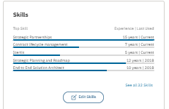
- 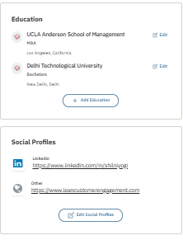

04/20 – Dashboard still very minimalistic. But we can add more later
Also, the Date posted can have the same options as you had in the Last Activity while searching for a job rather than a calendar.
04/20 – Date posted should have options such as “less than two days ago”, “less than a week ago”, “less than a month ago”, “less than 3 months ago”

- Also, “apply to a job” can be a button rather than a hyperlink in the banner.
- Also, the job details page should look similar to other pages:
04-20 – this page looks different from other pages as earlier (banner, etc)
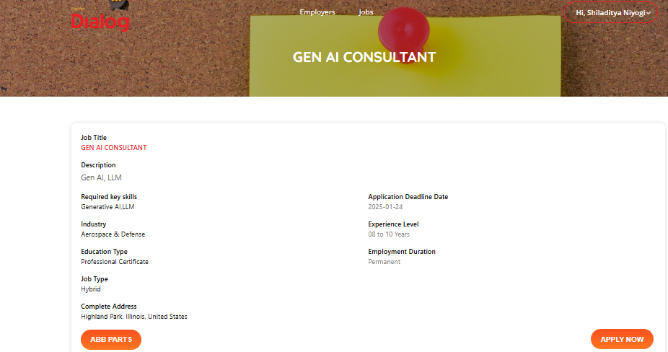
- The name of the company can be a hyperlinked field at the top as well, as opposed to a button at the bottom.
04/20 - Done

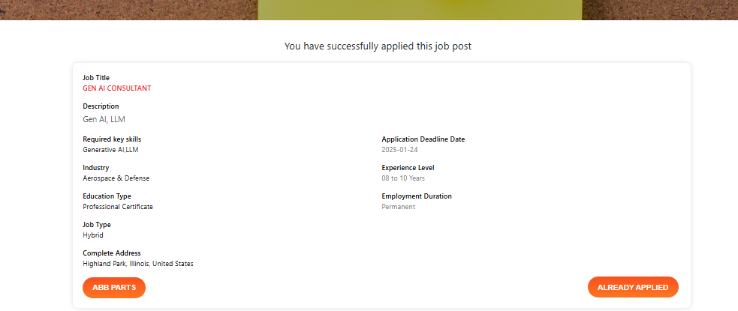
- When I apply, the page again needs to be similar. The page should say “Application successful”. We do not need the “Already Applied” button.
04/20 – Done

“Back to Dashboard” does not take back to dashboard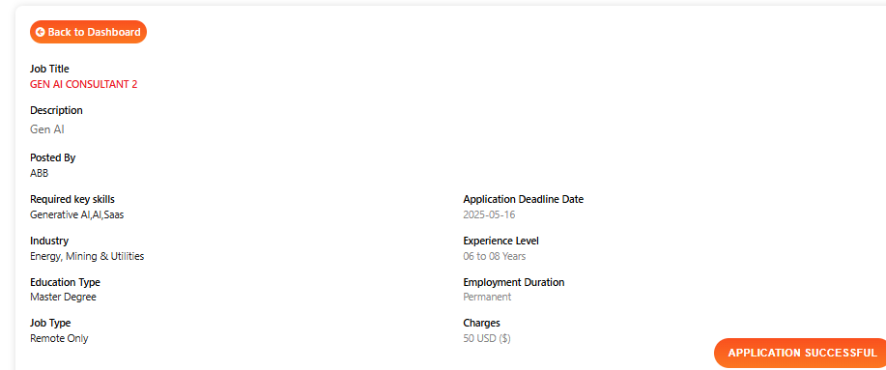
- Also, in the messages tab the search function does not seem to function.
04/20 – I don’t see the search function.
- If the candidate shares the availability for 5 hours, the employer cannot book a slice – and has to book the whole availability. Also, once selected they cannot change. Can we make them select 30 min slots only and can select multiple such slots for an interview?

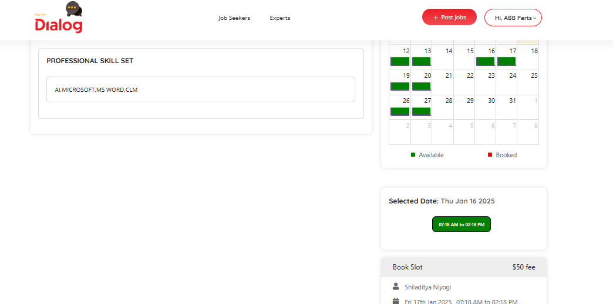
- Also, when I clicked twice, somehow it booked me twice for the same slot.
04/20 – this selection is no more taking place
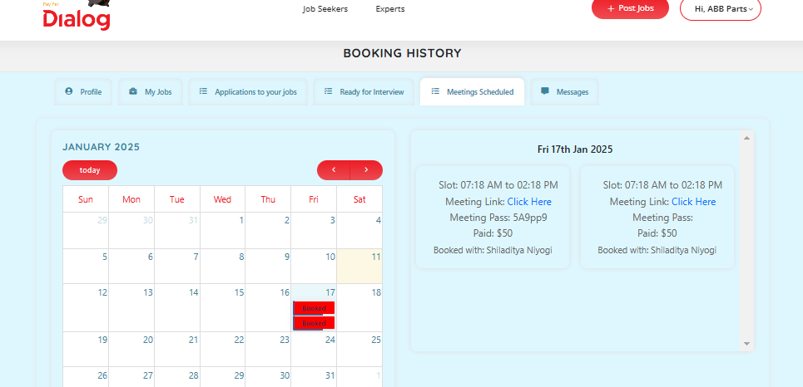

04/20 - You can use some third party apps to make it look more succinct:

- Can we also indicate the JOB ID or the role in the slots in the meetings scheduled tab? As I was chosen for two interviews how do I know which one to attend when?
04/20 – Could not reproduce as when clicking on slots it is not allocating an interview slot to the time selected (this used to work earlier)
- All upcoming interviews should reflect in the job seeker and employer dashboards.
04/20 – Could not reproduce as when clicking on slots it is not allocating an interview slot to the time selected (this used to work earlier)
- Also, I did not get an email notification. Can we have a notification sent to email as well as in the inbox (which is what the messages tab will become)?
04/20 – Did not see this happening when clicking on slots it is not allocating an interview slot to the time selected.

- How do we change the date if something comes up? When I clicked on another available slot, it didn’t do anything.
04/20 – Did not see this functionality
The search function needs some clarity.

